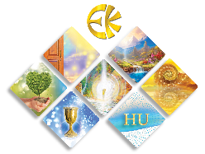  
**CHELA INVITATION LETTER**

Dear ECK Chela,

Most seekers discover the gift and blessings of the ECK teachings via a friend or family member.

In short, that means someone like you!

**Bring a Friend and Attend**

We are kicking off a Vahana program of *Raise Your Spiritual IQ!* events for those new to ECKANKAR in your region.

Do you know a friend or family member of any faith or background who’d like to enhance their spirituality and gain a new perspective on their purpose in life? We invite *you* to invite *them* to dynamic *Raise Your Spiritual IQ!* events. If you wish, you can join them for the exploration.

We’re now holding a concurrent *ECKopedia* book discussion for chelas. So while your friend or family member is attending the *Raise Your Spiritual IQ!* event, you can dive deep into the words and wonders of the *ECKopedia* with fellow ECK initiates.

You can find details at our Satsang Society website’s Event Calendar.

Thank you for being a shining light of ECK love in the world!

[RESA or RESA designee]